

LENANA SCHOOL 2025 PREDICTION
POSSIBLE KCSE EXAM
GEOGRAPHY
312/1
PAPER 1
TIME: 2¾ HOURS

NAME……………………………………………………………………………………….
SCHOOL……………………………………………… SIGN………………………..
INDEX NO……………………………………………. ADM NO……………………

Kenya Certificate of Secondary Education.

INSTRUCTIONS TO CANDIDATES.
- Write your name, class and admission number in the spaces provided above.
- Sign and write the date of the examination in the spaces provided above.
- This paper has two sections: A and B.
- Answer all the questions in sections A.
- Answer question 6 and any other two questions from Section B.

FOR EXAMINER’S USE ONLY
Section | Questions | Maximum  Score | Candidate’s  Score
A | 1 – 5 | 25
 | 6 | 25
B |  | 25
 |  | 25
 |  | Total Score

SECTION A
Answer all the questions in this section.
1. (a) State three effects of the rotation of the earth on its axis. (3 marks)
(b) Give two proofs that the earth is spherical. (2 marks)
2. (a) State three factors that influence how the wind blow. (3 marks)
(b) Identify two types of local winds. (2 marks)
3. (a) Identify two characteristics of minerals. (2 marks)
(b) Give three classifications of mechanically formed sedimentary rocks. (3 marks)
4. (a) Identify two scales used to measure earthquakes. (2 marks)
(b) State three effects of earthquakes. (3 marks)
5. (a) State three characteristics of Savanna vegetation. (3 marks)
(b) Give two uses of Savanna vegetation to man. (2 marks)

SECTION B
Answer question 6 and any other two questions from this section.
6. Study the map of Tambach (1:50,000 sheet 90/3) provided and use it to answer the following questions.
(a)(i)What is the magnetic variation of the area when the map was drawn? (1 mark)
(ii)Identify two types of scale on the map extract. (2 marks)
(b)(ii)What is the six figure grid reference of the cattle dip to the east of Kesup? (2 marks)
- Give the position of Lake Kamnorok by latitude and longitude. (2 marks)
(c)(i)Describe the relief of the area covered by the map. (6 marks)

(ii)Explain two factors that have favoured the establishment of saw mills in the area covered by the map. (4 marks)
- (i)Draw a square 12 cm by 12 cm to represent the region from northing 77 to northing 80 and west of easting 81. (1 marks)
(ii) On the square, mark and label:
- A plantation
- Road D 329
- A cattle dip
- The region representing Uasin Gishu district. (5 marks)
(iii) What is the scale of the sketch that you have drawn? (2 marks)

7. (a) (i) What is faulting? (2 marks)
(ii) Identify four types of faults. (4 marks)
(b) Using a well-labelled diagram, describe the formation of block mountains by tensional forces.
(8 marks)
(c) Explain four positive effects of faulting to human environment. (8 marks)
(d) You are supposed to carry out a field study on faulting in the Rift-Valley field study.
- State two objectives for your study. (2 marks)
- Identify two follow up activities you are likely to carry out after the field study. (2 marks)

8. (a) (i) Identify three processes through which waves erode the coastline. (3 marks)
(ii) Apart from blowholes, list three features that are produced by wave erosion along the coast. (3 marks)
(b) With aid of well-labelled diagrams, describe how a blowhole is formed. (8 marks)
(c) Describe how a spit is formed. (4 marks)
(d) COHS students conducted a field study on coastal features along the Kenyan coast.
- List three features of coastal emergence they are likely to have studied. (3 marks)
- State four ways in which features resulting from coastal emergence are of significance to Kenya. (4 marks)

9. Use the world map below to answer questions (a) and (b).
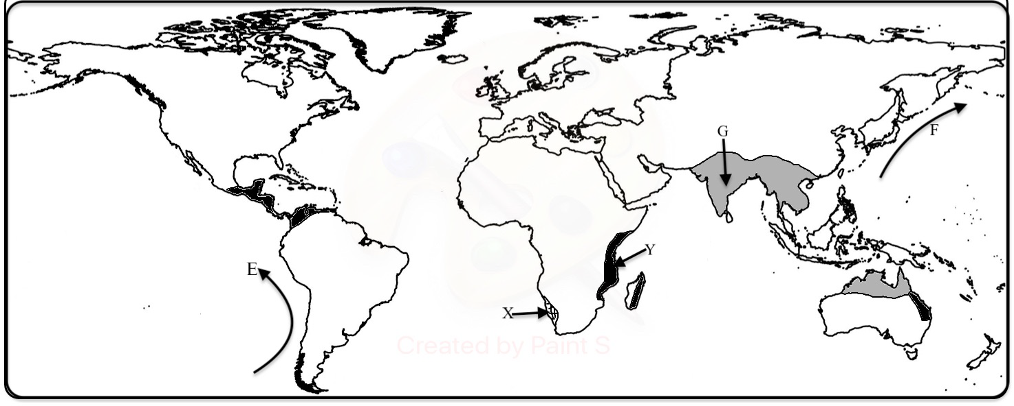

(a) (i) Identify the climate marked X and Y. (2 marks)
(ii) Name the ocean currents marked E and F. (2 marks)
(b) Describe the characteristics of the climate marked G. (8 marks)
(c) Explain how the following factors influence climate:
- Latitude; (2 marks)
- Aspect; (2 marks)
- Configuration of the coastline. (2 marks)
(d) (i) State three factors that influences atmospheric pressure. (3 marks)
(ii) Describe how relief rainfall is formed. (4 marks)

10. (a) State four factors that determine the amount of surface run-off. (4 marks)
(b) Describe three ways in which a river transport its load. (6 marks)
(c) Using diagrams,describe the following drainage patterns:
(i) Dendritic; (2 marks)
(ii) Trellis; (2 marks)
(iii) Centripetal. (2 marks)
(d) (i) What is a delta? (2 marks)
(ii) State three ideal conditions under which a delta may be formed. (3 marks)
(iii) State four factors that lead to river deposition. (4 marks)

